

Foundations of Programming

Assignment No. : 06
PROBLEM STATEMENT:Write a C function to compute the factorial of a number with and without recursion.

OBJECTIVE:

To demonstrate two different approaches for calculating the factorial of a number: iterative (non-recursive) and recursive, showcasing the versatility of problem-solving methods in programming.

THEORY:
- Explain the difference between the iterative and recursive approaches to calculating the factorial of a number.
- What is the base case in the recursive function for computing factorials, and why is it necessary?
- How does the program handle invalid input, such as negative numbers, and why is this important?
PLATFORM: Linux

INPUT: #include <stdio.h>

int factorial(int n) {
if (n == 0 || n == 1)
return 1;
else
return n * factorial(n - 1);
}

int main() {
int num;

printf("Enter a number: ");
scanf("%d", &num);

if (num < 0) {
printf("Factorial is not defined for negative numbers.\n");
} else {
printf("Factorial using recursion: %d\n", factorial(num));
}

return 0;
}
OUTPUT:
Enter a number: 45
Factorial using recursion: 0
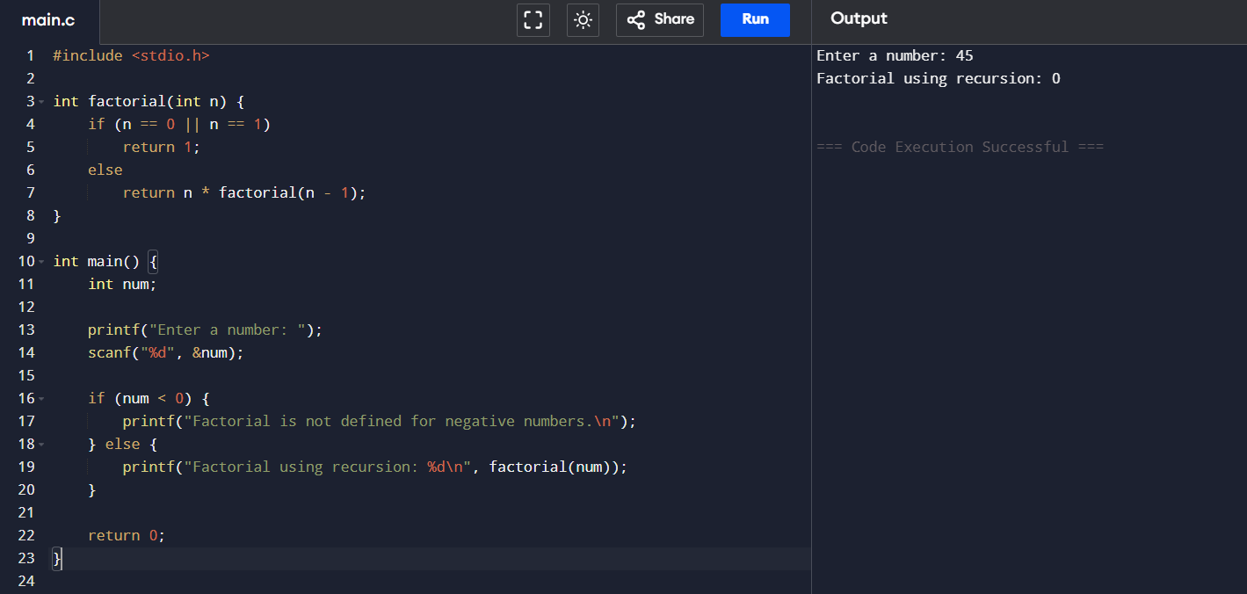
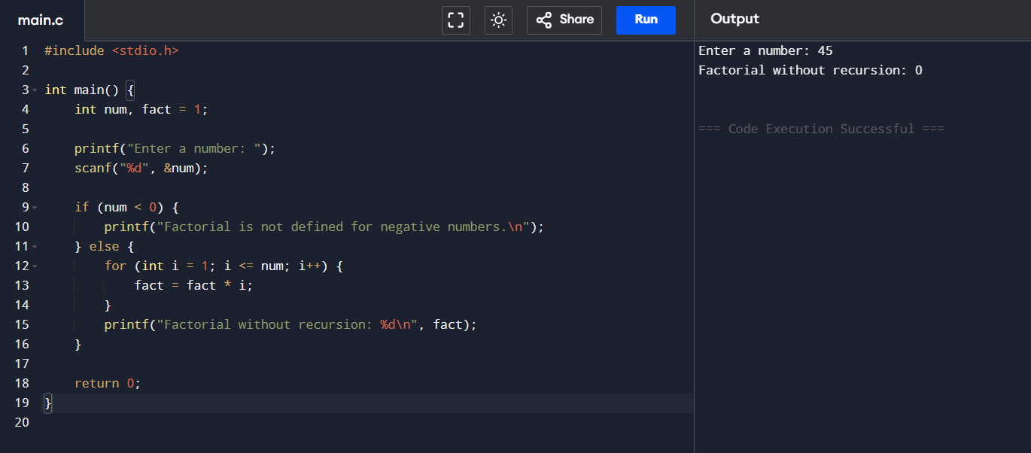
CONCLUSION: Thus, we have successfully executed factorial of a number with and without recursion.

FAQs:
1. What is the purpose of calculating factorial in programming?
2. What is the difference between recursive and non-recursive (iterative) methods?

